**Homework 5**

**Please do not use array, self-defined function in this homework.**

**Problem1: The Integration**

**(I). Using the Trapezoidal Rule:**

**The integral of the function *f(x)*, evaluated from a to b, is expressed as**

** that represents the area under the function *f(x)* from x=a to x=b ,as**

*y*



*x*

*f*(*x*)

*b*

*a*

Fig 1: **Area under a curve**

*y*

*x*

*f*(*x*)

*y*1

*y*2

*y*3

*y*4

*y*5

*a = x*1

*x*2

*x*3

*x*4

*x*5 = *b*

Fig 2: **Spaced intervals**

*y*

*x*

*f*(*x*)

*y*1

*y*2

*y*3

*y*4

*y*5

*a = x*1

*x*2

*x*3

*x*4

*X5*= *b*

A1

A2

A3

A4

*h = x*2 － *x*1

= *x*3 － *x*2 = **…**

Fig 1: **Four trapezoids**

**The total area under the function *f(x)* from** *x*1 **to** *x*5 **is** A1**＋**A2 **＋**A3**＋**A4**=**

**× ( ＋****) ×***h*＋**× (＋** **) ×***h*＋**× (＋ )×***h*＋**× ()****×***h*

＝× **) ＋（＋** **＋ ）×** *h*

**＝**＝× 〔(**) ＋ 2 ×（$y_{2}$ ＋ $y_{3}$** **＋ $y_{4}$）**〕

In general, Area = $\int_{a}^{b}{f\left(x\right)dx}$

= $\frac{h}{2}$ [ *f(a)* + *f(b)* + 2 $\sum_{i=2}^{n}{f(x_{i)}}$]  **where *n*=4**

**where *h* = , Note that the interval〔*a, b*〕is divided into *n* subintervals**

**(II). Using the rectangular rule:**

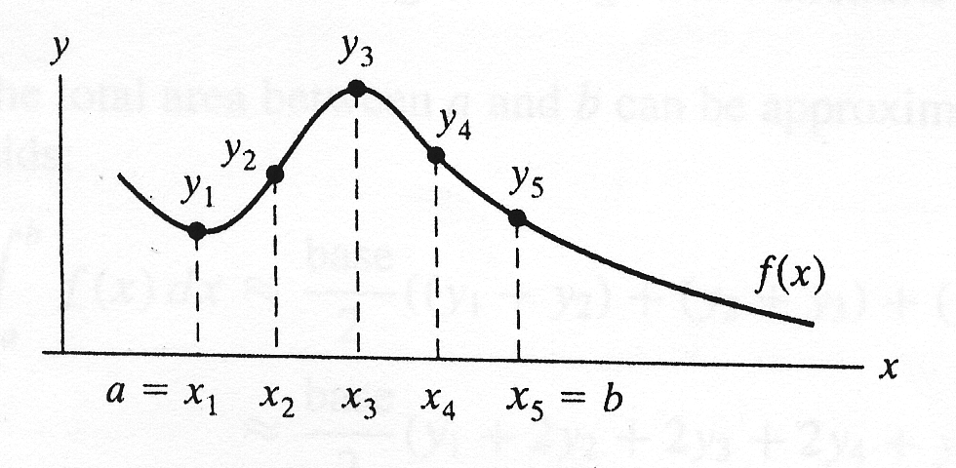

*h = x*2 － *x*1

= *x*3 － *x*2 = **…**

**The total area under the function *f(x)* from $x_{1}$ to $x_{5}$** **is**

*h* × $y_{1}$**＋***h* × $y_{2}$**＋***h* × $y_{3}$**＋** *h* × = *h* ×（$y_{1}$**＋ $y_{2}$** **＋ $y_{3}$** **＋ $y_{4}$**  ）**where *n*=4**

**In general, *Area* =  =** *h* × $\sum_{i=1}^{n}{f(x_{i})}$

(a). Using trapezoidal rule and rectangular rule to find the area bounded by

From a=5, b=15 f(x) = $5x^{3}+2x^{2}+7x+3$.  
 Given that integration interval h = (b-a)/n

(b). The interval [a, b] is divided into n subintervals.

(c). Please let user input n continuously to calculate the results and stop the

program when inputting CTRL+Z.

(d). Please show the answer to the 8th decimal place.

**Input/Output Example:**

Please input n: 100000

Trapezoidal Rule: 65396.66666920

Rectangular Rule: 65395.83066920

Please input n: 500000

Trapezoidal Rule: 65396.66666677

Rectangular Rule: 65396.49946677

Please input n: 50000

Trapezoidal Rule: 65396.66667680

Rectangular Rule: 65394.99467680

Please input n: ^Z

**Problem 2:**

Write a program that prompts the user to input three numbers. The program should then output the numbers in ascending order.(由小排到大)

Please let user input data continuously and stop the program when inputting **CTRL+Z**. No ternary operator in this problem.

**Input/Output Example:**

Input 3 numbers: 100 205 300

From smallest to largest is: 100 < 205 < 300

Input 3 numbers: 300 205 100

From smallest to largest is: 100 < 205 < 300

Input 3 numbers: 205 100 300

From smallest to largest is: 100 < 205 < 300

Input 3 numbers: ^Z

**Problem 3:**

Write a program to convert binary numbers to decimal.

( Hint: First you can decompose a binary number into separate digits.)

Let user continuously input binary number and stop the program when inputting CTRL+Z.

**Input/Output Example:**

Please input binary number: 1010

Decimal: 10

Please input binary number: 101

Decimal: 5

Please input binary number: 111111111

Decimal: 511

Please input binary number: ^Z

**Problem 4:**

Suppose you can buy a chocolate bar from the vending machine for $1 each.　Inside every chocolate bar is a **coupon**. You can redeem **seven coupons** for one chocolate bar from the machine. You would like to know how many chocolate bars you can eat, including those redeem via coupon, if you have ***n*** dollars.

For example, if you have 20 dollars then you can initially buy 20 chocolate bars. This gives you 20 coupons. You can redeem 14 coupons for **two** additional chocolate bars. This additional chocolate bars give you **two more** **coupons**, so you now have a total of **eight coupons**. This gives you enough to redeem for **one final chocolate bar**. **As result you have 23 chocolate bars and two leftover coupons.**

Write a program that inputs the number of dollars and outputs how many chocolate bars you can collect after spending all your money and redeeming as many coupons as possible. Also output the number of leftover coupons, and stop the program when inputting **CTRL+D**.

**Input/Output Example:**

Please input the number of dollars: 321

The number of chocolate bars you can collect is 374

The number of leftover coupons is 3

Please input the number of dollars: 123

The number of chocolate bars you can collect is 143

The number of leftover coupons is 3

Please input the number of dollars: ^D

**Problem 5.**

Write a program that prompts the user to input the x-y coordinate of a

point in a Cartesian plane. The program should then output a message

indicating whether the point is the origin, is located on the x (or y) axis,

or appears in a particular quadrant.

**For example:**

**(0,0) is the origin**

**(4,0) is on the x-axis**

**(0,-3) is on the y-axis**

**(-2,3) is in the second quadrant**

**(-1,-9) is in the third quadrant**

Please let user input data continuously and stop the program when

inputting CTRL+Z. No ternary operator in this problem.

**Input/Output Example:**

Input coordinate x, y: 25 -25

(25, -25) is in the fourth quadrant.

Input coordinate x, y: -25 -25

(-25, -25) is in the third quadrant.

Input coordinate x, y: 25 25

(25, 25) is in the first quadrant.

Input coordinate x, y: -25 25

(-25, 25) is in the second quadrant.

Input coordinate x, y: 0 25

(0, 25) is on the y-axis.

Input coordinate x, y: 25 0

(25, 0) is on the x-axis.

Input coordinate x, y: 0 0

(0, 0) is the origin.

Input coordinate x, y: ^Z

**Problem 6.** Use the switch syntax to solve this problem:

Write a program that mimics a calculator.

(a). The calculator provides only 4 arithmetic operations: +, -, *, /.

(b). The program should take as input one integer, the operator that the

operation to be performed and the other integer.

(c). It should then output the numbers, the operators, and the operation result.

(d). For division, if the denominator is zero, output an error message.

(e). If the input operator is not one of +, -, * , / then also output error message.

(f). The user can continue to execute the program until the user inputs ‘N’ or

‘n’ to stop the program.

**Input/Output Example:**

Please input integer, the operator and integer:

12*6

Answer: 12 * 6 = 72

Continue or not: y

Please input integer, the operator and integer:

7-9

Answer: 7 - 9 = -2

Continue or not: y

Please input integer, the operator and integer:

8%2

Error: incorrect operator!!!

Continue or not: y

Please input integer, the operator and integer:

12/0

The denominator cannot be zero.

Continue or not: y

Please input integer, the operator and integer:

12/5

Answer: 12 / 5 = 2

Continue or not: y

Please input integer, the operator and integer:

12+5

Answer: 12 + 5 = 17

Continue or not: n

**Problem 7.** Write a menu-driven program that has the following options:

1. Factorial of a number
2. Prime or not
3. Odd or even
4. Exit

Once a menu item is selected, the appropriate action should be taken and once this action is finished, the menu should reappear. Unless the user selects the “Exit” option, the program should continue to work. In each option, please let user input data continuously and stop executing the selected option when inputting CTRL+Z.

**Input/Output Example:**

Please select option (1~4)=> 1

Input number: 19

19! = 121645100408832000

Input number: 10

10! = 3628800

Input number: ^Z

******** Optiopns ********

1.Factorial of a number

2.Prime or not

3.Odd or even

4.Exit

--------------------------

Please select option (1~4)=> 10

Error: incorrect option!!!

******** Optiopns ********

1.Factorial of a number

2.Prime or not

3.Odd or even

4.Exit

--------------------------

Please select option (1~4)=> 2

Input number: 100

100: Not a prime number.

Input number: 13

13: Prime number.

Input number: 97

97: Prime number.

Input number: ^Z

******** Optiopns ********

1.Factorial of a number

2.Prime or not

3.Odd or even

4.Exit

--------------------------

Please select option (1~4)=> 3

Input number: 23

23: Odd number.

Input number: 32

32: Even number.

Input number: ^Z

******** Optiopns ********

1.Factorial of a number

2.Prime or not

3.Odd or even

4.Exit

--------------------------

Please select option (1~4)=> 4

See you!!!